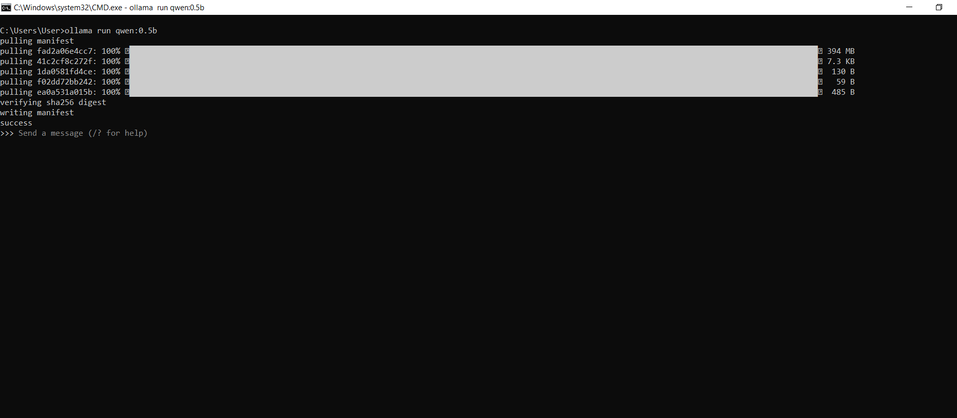

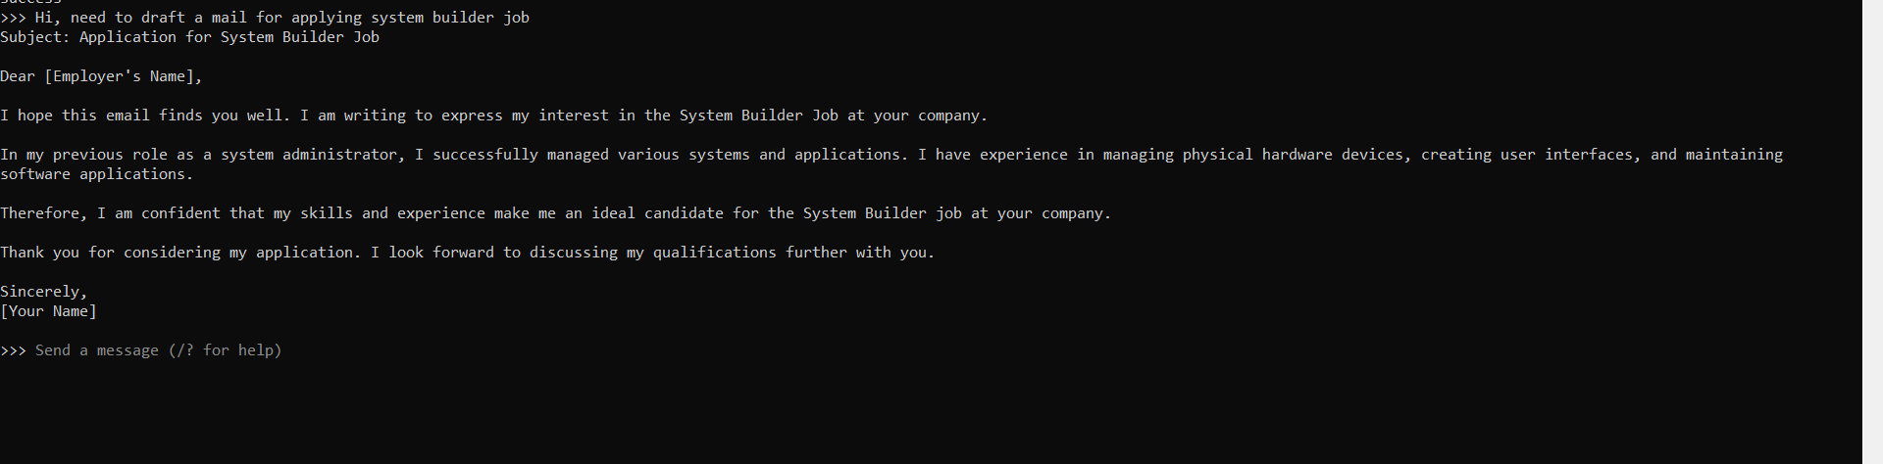

OPEN LLM
Qwen 3.5
Vision
Tools
Thinking
cloud

context : 256K tokens
Parameter:

Input: Text, image,Video

Model | Meaning
0.8B | 80 crore parameters
2B | 200 crore
4B | 400 crore
9B | 900 crore
27B | 2700 crore
35B | 3500 crore
122B | 12200 crore

nemotron-3-ultra

Tools
Thinking
Cloud

context : 256K tokens
Input : Text
Usage: High
Size: 550B Parameter

CLOSED LLM

Opus 4.8-- Powerful model for complex work.

Input$ 5 / MTok
Output$ 25 / MTok
Context window 1M tok
Max output 128K tok
Knowledge cutoff jan 2026

